THE ZOOM LINK FOR ALL SERVICES
Goodland New Testament's Zoom Meeting: ID: 839 9965 2681
Passcode: 3LfSf3
ZOOM WEEKLY ..,.CHURCH TIMES
TUESDAY NIGHTS 7:00 p.m.
Men meet on 1st & 3rd Tuesdays

WEDNESDAY NIGHTS 7:00 p.m.
Women meet on 2nd & 4th Wednesday of the month

=================================
ZOOM PRAYER & FASTING
****
WEDNESDAY 10:00 a.m

“The Engine Room of the Church”
ZOOM BIBLE STUDY
THURSDAYS 7:00 p.m
Around the WORD in 90 Minutes!!
For spiritual growth & development
===============================
ZOOM EARLY MORNING PRAYER
EVERY 1st SATURDAY- 6:30 a.m.
================================
+++++++++++++++++++++++++
EVENT HIGHLIGHTS

Please note that our Mother’s Day service will be held on Sunday, May 10, 2026 at 10 am. This year we celebrate our Mothers with a luncheon in the church’s courtyard. Please let us know by Sunday, May 3, 2026 if you will be having lunch with us.
++++++++++++++++++++++++
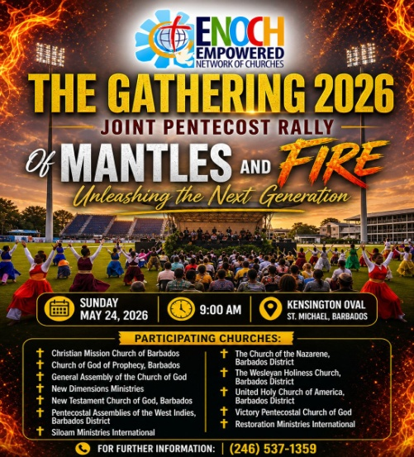

BIRTHDAYS
Sis Gina Dowell 1st
Sis. Sierra Austin 4th
Sis. Sharon Grant 13th
Min. Rosalyn Lovell 15th
Bro. Hampden Lovell 23rd
Bro. Keshon Francis 24th
Sergio Jones 25th
Rev. Ruth Hinds 30th
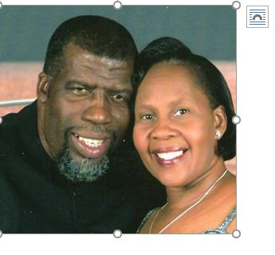

Pastors H. Meredith & Ruth Hinds
We are your Pastors: we can help. Please contact us when you need us
Tel # 546-2228 or 823-6440
/256-0900

SUNDAY SCHOOL
Is still one of the stabilizing institutions within our society. Please send your children to join us on Sundays. We begin at 8:45 am.
+++++++++++++++++++++++++++++


NEW TESTAMENT CHURCH
OF GOD
GOODLAND


Goodland Main Road
, St. Michael

A WARM WELCOME AWAITS YOU!

“Equipping lives for service”

This month we are asking you to
help us celebrate our
MOTHERS
MAY 2026

‘For with God nothing shall be impossible’. Luke 1: 37

ALIGN/ADVANCE/ACCELERATE
From the Pastor’s Desk……..
BEING FILLED WITH GOD’S POWER

When you think about powerful people, some that might come to mind are billionaires, superheroes or heads of big companies. They often share common traits - being successful, confident, and having influence. However, Here is a truth: as God’s child, you have access to power that comes from God Himself, which accomplishes much more than what money, position or influence can.

In Ephesians 3, Paul says the power that comes from God enables us to effectively fulfil everything that He has called us to. It is supernatural, giving us strength beyond our human capacity and accomplishing things of eternal value! Here’s how we can experience more of His power flowing through us:

Attempt greater things for God. Think about the times when you avoided God’s plans because of your own limitations. It may be a time you held back from sharing the gospel because you feared rejection, or a time when you said ‘no’ to discipling or mentoring a newer believer because you felt inadequate. From today, decide that you will step out boldly to do these things, because it is God’s power working within you that enables you to do them!

Ask for bigger things with boldness. He is able to do much more than we can ask or imagine! God is creative, strong, powerful and able to do the impossible. He can go way past the limitations we face, and we are only limited by what we are willing to ask and expect. So have faith and ask God for bigger things, and experience His power in action!

Be constantly filled with the Holy Spirit. Acts 1:8 says that you will receive power when the Holy Spirit comes upon you! The mighty power that works within us is the power of the Holy Spirit. Ask God to baptize you in the Holy Spirit. As He does, His power overflows in us and gives us strength and boldness to accomplish His will.

Living under an Open Heaven gives us full access to God’s power, so let us walk boldly in it!
REFLECT:
What can we do to remind ourselves of God’s power in our difficult situations?
Think of a difficult situation you’re going through. How would you respond differently now knowing that you have God’s power within you?

PRAYER

Dear God, thank You for empowering me to accomplish Your will and to overcome difficult situations. Give me the faith to believe that as I set out to do Your work, You will give me the power I need. In Jesus’ name I pray, Amen.
‭Ephesians 3:20 NIV‬
[20] Now to him who is able to do immeasurably more than all we ask or imagine, according to his power that is at work within us,

MAY WORSHIP SERVICES
May 03 - 8:45 AM MORNING
Sunday School
10 AM
Moderator –
Worship Leader – Sis. Kimberley Paul

Sermon – Rev. Meredith Hinds
+++++++++++++++++++++++++++++

MAY WORSHIP SERVICES CONT’D
May 10 - 10 AM MORNING
MOTHERS’ DAY CELEBRATION
Moderator – Sis. Rhonda Duke
Worship Leader – Sis. Marcene White
Sermon – Rev. Feeonan Austin

LUNCH WILL BE SERVED AT 1 PM +++++++++++++++++++++++++++++
May 17 - 8:45 AM MORNING
Sunday School
May 17 - 10 AM MORNING
Moderator: Sis. Rosalyn Lovell
Worship Leader: -Sis. Janelle Woodroffe
Sermon: Sis. Abriana Forde
COMMUNION
+++++++++++++++++++++++++++++
May 24 – PENTECOST SUNDAY
THE GATHERING 2026
JOINT PENTECOSTAL RALLY
VENUE: KENSINGTON OVAL
TIME: 9:00am
THEME: “OF MANTLES & FIRE- unleashing the next generation”
Let us continue to pray for a supernatural move of God!
++++++++++++++++++++++
May 31–GO MONTH EVANGELISTIC OUTREACH
Moderator: Sis. Rosalyn Lovell
Worship Leader- Rev. Feeonan Austin

